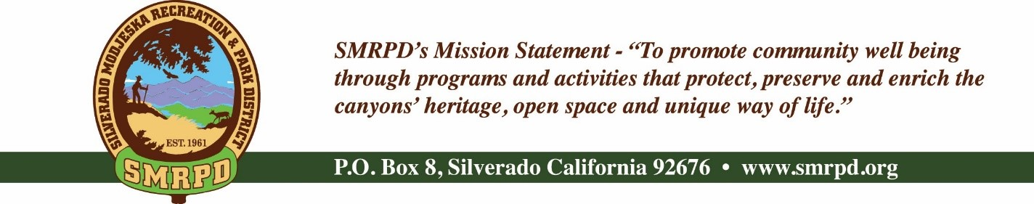
SMRPD REGULAR MEETING
Tuesday, November 22nd, 2022 at 6:30 pm
Silverado Community Center
27641 Silverado Canyon Road
Board of Directors |  | Staff
Isabell Kerins: | President | Laurie Briggs: | SCC Program Director
Julie “Rusty” Morris: | Vice-President | JoMarie Varela | SMRPD Administrator
Michele Conklin: | Treasurer | Steve Reighart: | Caretaker
Jessie Bullis | Secretary | Stephanie Dodge: | Bookkeeper
Kevin Topp: | Director | Sasha Sill: | Senior Services
 |  | Danny Ater: | Maintenance

AGENDA

NOTE: MEETINGS WILL BE HELD IN PERSON AND BY ZOOM, IF POSSIBLE, UNTIL FURTHER NOTICE
ZOOM LINK

PUBLIC COMMENTS: A person wishing to comment on an Agenda item should wait for the President to request comments and then unmute his or her phone, ask to make a comment, and wait for the President to recognize him/her. You have three (3) minutes to complete those comments, unless a longer time is granted. No speaker may allot his or her time to others.

Comments on Agenda items: Comments concerning matters on the Agenda will be heard at the time the matter is considered.

Comments on Non-Agenda items: Comments concerning matters not on the Agenda will be heard during the Public Comment section of the Agenda. A speaker's comments should be within the subject matter jurisdiction of the SMRPD.

Please note that if you are addressing the Board on items not on the Agenda, the Brown Act does not allow Board discussion of such items because they are not on the Agenda and thus were not noticed publicly. Therefore, the Board may only do the following: Refer the matter to staff, ask for additional information or request a report back, or give a very limited factual response. Your comments may be placed on the Agenda for future discussion. Non-Agenda comments are limited to 3 minutes each with a total of 15 minutes.

- CALL TO ORDER
- ROLL CALL
- CONSENT CALENDAR – JoMarie Varela

Action Item #1: Approve and file minutes of the SMRPD General Board Meetings dated September 20th, 2022 and October 18th 2022 and Special Meeting dated November 15th, 2022

- TREASURER'S REPORT – Stephanie Dodge

Action Item #2: Approve and file Financials for SMRPD October 2022
Action Item #3: Approve and file Financials for SCC for October 2022

- FINANCE COMMITTEE
  - Minutes from Finance Committee meeting dated November 15th, 2022
  - Petty cash discussion – Write-off will be made through 6/22 Audit updates per Auditor

Action Item #4: Write off $500 for missing petty cash

  - Year end bonuses/gift discussion

Action Item #5: Approve gift cards for staff as presented

  - Silverado Children’s Center – Write-off of Covid Credits from 2020 – Stephanie Dodge
      - Update

- OTHER DISTRICT BUSINESS
  - Commendation for Kevin Topp
  - Ad Hoc – Candidate Engagement
    - Election Results
    - Swearing in Ceremony 11/30 at Noon at Silverado Community Center
  - Ad Hoc – Handbooks
    - Status update
      - SCC Employee Handbook
      - SMRPD Director and Employee Policy and Procedures Manual
    - Update to Conference and Travel Reimbursement
- Conference and Travel Reimbursement: Directors and employees are entitled to yearly reimbursement of expenses for seminars, conferences and continuing education not to exceed $500 for conference or seminar attendance, as well as $150 per day stipend for lodgings, food or miscellaneous items, and mileage at allowable IRS rates for given year. Additional expenses over and above the agreed upon reimbursement must be approved by the entire Board. Employees must submit a request to the Personnel Committee which will include a statement as to why they desire to attend and how the particular seminar, conference or continuing education benefits the district. A brief summary of findings including benefit of conference to the district shall be presented to the board within one month of completion. An expense record must be turned in with receipts to verify each expense.
Action Item #6: Approve update to Handbook for Conference and Travel Reimbursement as presented

- SILVERADO CHILDREN’S CENTER (SCC) OVERSIGHT COMMITTEE – Laurie Briggs
  - Minutes from Committee Meeting dated November 15th, 2022
  - Program Report with updates on facilities and enrollments
  - Friends of Silverado Children’s Center Updates – Sarah Pizzaruso
  - Write-off of $1,457.09 from accounts payable for miscellaneous items

Action Item #7: Approval to write-off $1,457.09 for Children’s Center accounts receivables as presented

- FACILITIES/SAFETY/MAINTENANCE COMMITTEE
  - Minutes from October 24th and November 15th meetings
  - Safety Inspections
    - Silverado Community Center
    - Modjeska Community Center/Park
    - Silverado Children’s Center
  - Rentals – JoMarie Varela
    - New for Approval: -
      - December 3, 2022 – Private Event
      - December 17, 2022 – Private Event

Action Item #8: Approve new Facilities Rental Agreements as presented

  - Insurance required for movie provider

- RECREATION COMMITTEE
- COMMUNICATIONS COMMITTEE
- INSURANCE COMMITTEE
- PUBLIC COMMENTS
- BOARD COMMENTS
  - CLOSED SESSION Labor Negotiations pursuant to Govt. Code Section 54957: District Negotiator: Laurie Briggs, Director, Silverado Children’s Center; Negotiating with unrepresented Employee(s)/Subcontractors regarding terms and conditions of employment
- ADJOURNMENT

The next regular meeting of the SMRPD Board of Directors will be at 6:30 PM on Tuesday, December 27th , 2022 at the Silverado Community Center. Please note the swearing in ceremony for new directors will be held Friday, November 30th, 2022 at Noon at the Silverado Community Center.

It is the intent of the Silverado Modjeska Recreation and Park District to comply with the Americans with Disabilities Act (ADA) in all respects. If, as an attendee or a participant at this meeting, you will need special assistance beyond what is normally provided, the Silverado Modjeska Recreation and Park District will attempt to accommodate you in every reasonable manner. Please contact the District President at (949) 887-1910, at least 48 hours prior to the meeting to inform us of your particular needs and to determine if accommodation is feasible. Please advise us at that time if you will need accommodations to attend or participate in this meeting.

