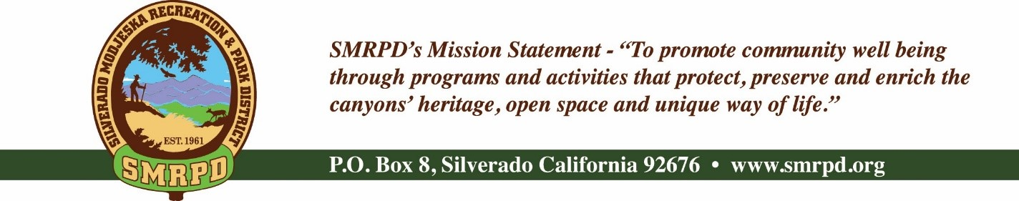
Facilities Committee Meeting
Tuesday, November 15th, 2022, at 2 PM
Silverado Community Center

Committee Members |  | Staff
Isabell Kerins: | Chair | JoMarie Varela: | Administrator
Julie “Rusty” Morris: |  | Steve Reighart: | Caretaker
 |  | Danny Ater: | Maintenance
 |  | Agenda
PUBLIC COMMENTS: A person wishing to comment on an Agenda item should wait for the President to request comments and then unmute his or her phone, ask to make a comment, and wait for the President to recognize him/her. You have three (3) minutes to complete those comments, unless a longer time is granted. No speaker may allot his or her time to others.
Comments on Agenda items: Comments concerning matters on the Agenda will be heard at the time the matter is considered.
Comments on non-Agenda items: Comments concerning matters not on the Agenda will be heard during the Public Comment section of the Agenda. A speaker's comments should be within the subject matter jurisdiction of the SMRPD.
Please note that if you are addressing the Board on items not on the Agenda, the Brown Act does not allow Board discussion of such items because they are not on the Agenda and thus were not noticed publicly. Therefore, the Board may only do the following: refer the matter to staff, ask for additional information or request a report back, or give a very limited factual response. Your comments may be placed on the Agenda for future discussion. Non-Agenda comments are limited to 3 minutes each with a total of 15 minutes.

- CALL TO ORDER
- ROLL CALL
- CONSENT ITEMS
  - Minutes from 10/24/2022 meeting
- NEW BUSINESS
  - Bid to paint facilities
- OLD BUSINESS
  - Capri Visit Follow-up
  - Construction Schedule
- PUBLIC COMMENTS
- BOARD COMMENTS
- ADJOURNMENT

The next regular meeting of the Facilities Committee is December 20th, 2022 at 2 PM at the Silverado Community Center.
It is the intent of the Silverado Modjeska Recreation and Park District to comply with the Americans with Disabilities Act (ADA) in all respects. If, as an attendee or a participant at this meeting, you will need special assistance beyond what is normally provided, the Silverado Modjeska Recreation and Park District will attempt to accommodate you in every reasonable manner. Please contact the District President at (949) 887-1910, at least 48 hours prior to the meeting to inform us of your particular needs and to determine if accommodation is feasible. Please advise us at that time if you will need accommodations to attend or participate in this meeting.
on a regular basis.

It is the intent

