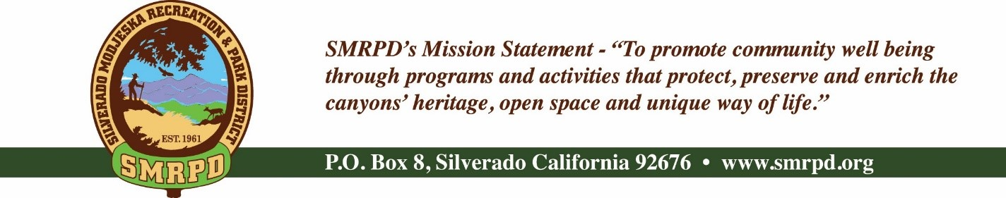
Silverado Children’s Center Oversight Committee Meeting
Tuesday, September 13, 2022, at 9:00 AM
Silverado Community Center
27641 Silverado Canyon Road, Silverado, CA
NOTE – THIS MEETING HAS BEEN CANCELLED
Committee Members |  | Staff
Isabell Kerins: | President | Laurie Briggs: | SCC Director
Julie “Rusty” Morris: | Vice-President | Sarah Pizzaruso: | Friends of SCC
Stephanie Dodge: | Tuition Specialist
 |  | Agenda
PUBLIC COMMENTS: A person wishing to comment on an Agenda item should wait for the President to request comments and then unmute his or her phone, ask to make a comment, and wait for the President to recognize him/her. You have three (3) minutes to complete those comments, unless a longer time is granted. No speaker may allot his or her time to others.
Comments on Agenda items: Comments concerning matters on the Agenda will be heard at the time the matter is considered.
Comments on non-Agenda items: Comments concerning matters not on the Agenda will be heard during the Public Comment section of the Agenda. A speaker's comments should be within the subject matter jurisdiction of the SMRPD.
Please note that if you are addressing the Board on items not on the Agenda, the Brown Act does not allow Board discussion of such items because they are not on the Agenda and thus were not noticed publicly. Therefore, the Board may only do the following: refer the matter to staff, ask for additional information or request a report back, or give a very limited factual response. Your comments may be placed on the Agenda for future discussion. Non-Agenda comments are limited to 3 minutes each with a total of 15 minutes.

- CALL TO ORDER
- ROLL CALL
- PROGRAM REPORT UPDATE - Laurie
- NEW BUSINESS
  - Federal Holidays
  - New Hires-Laurie
  - Job Descriptions
    - SCC Program Director
    - SCC Administrative Director
  - Current To Do Priority List (see below Carmody Walk-Thru)
  - Credit card spending limit issue/Home Depot

- OLD BUSINESS
  - Van Registration Update – Laurie
  - Construction Update- Carmody Walk-Thru 9/15/22
  - Art and Wine Fundraiser 9/24/22
VI. ADJOURNMENT

The next regular meeting of the SCC Oversight Committee will on Tuesday, October 11th, 2022, at 9 AM at the Silverado Community Center.

