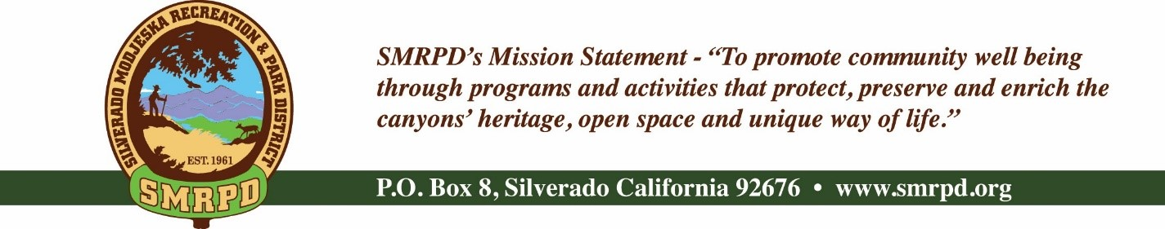
Facilities Committee Meeting
Tuesday, September 13th, 2022, at 10:30 AM
Silverado Community Center

NOTE – THIS MEETING HAS BEEN CANCELLED

Committee Members |  | Staff
Isabell Kerins: | President | JoMarie Varela: | Administrator
Julie “Rusty” Morris: | Vice-President | Steve Reighart: | Caretaker
 |  | Danny Ater: | Maintenance
 |  | Agenda
PUBLIC COMMENTS: A person wishing to comment on an Agenda item should wait for the President to request comments and then unmute his or her phone, ask to make a comment, and wait for the President to recognize him/her. You have three (3) minutes to complete those comments unless a longer time is granted. No speaker may allot his or her time to others.
Comments on Agenda items: Comments concerning matters on the Agenda will be heard at the time the matter is considered.
Comments on non-Agenda items: Comments concerning matters not on the Agenda will be heard during the Public Comment section of the Agenda. A speaker's comments should be within the subject matter jurisdiction of the SMRPD.
Please note that if you are addressing the Board on items not on the Agenda, the Brown Act does not allow Board discussion of such items because they are not on the Agenda and thus were not noticed publicly. Therefore, the Board may only do the following: refer the matter to staff, ask for additional information or request a report back, or give a very limited factual response. Your comments may be placed on the Agenda for future discussion. Non-Agenda comments are limited to 3 minutes each with a total of 15 minutes.

- CALL TO ORDER
- ROLL CALL
- NEW BUSINESS
  - Per Capita Grant project walk-through-Update to State
  - Facility Rentals- JoMarie Varela
    - Joyfest – post event review for next event 11/6/22
    - Sept. 8, 2022, Fire & Ice Community Potluck -sponsor w/logo
    - October 03-14 (pending insurance) Country Fair (waiting on insurance from ICL)
    - New for Approval
      - Memorial of Life request– 10/23/22
      - Caroline /Bruce Day Art event - 11/12/22
      - Christmas in the Canyons

- OLD BUSINESS
  - Inventory of concert equipment and keys to cabinet
  - Buller/Modjeska Park weed mitigation proposal: Specialized Tree Works Quote
  - Cooling Centers suggestions. What worked/what didn’t

VI. ADJOURNMENT

The next regular meeting of the Facilities Committee will be October 11th, 2022, at the Silverado Community Center.

