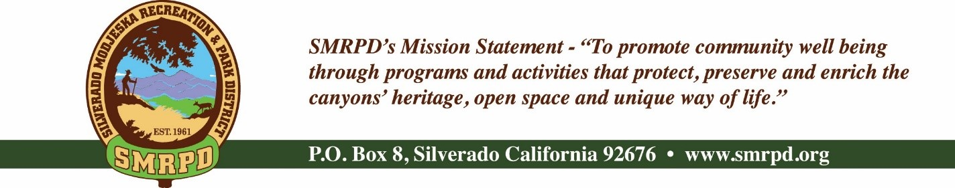
Facilities Committee Meeting
Tuesday, August 2nd, 2022, at 3:30 PM
Silverado Community Center

Committee Members |  | Staff
Isabell Kerins: | President | JoMarie Varela: | Administrator
Julie “Rusty” Morris: | Vice-President | Steve Reighart: | Caretaker
 |  | Danny Ater: | Mainteance
 |  | Agenda
PUBLIC COMMENTS: A person wishing to comment on an Agenda item should wait for the President to request comments and then unmute his or her phone, ask to make a comment, and wait for the President to recognize him/her. You have three (3) minutes to complete those comments, unless a longer time is granted. No speaker may allot his or her time to others.
Comments on Agenda items: Comments concerning matters on the Agenda will be heard at the time the matter is considered.
Comments on non-Agenda items: Comments concerning matters not on the Agenda will be heard during the Public Comment section of the Agenda. A speaker's comments should be within the subject matter jurisdiction of the SMRPD.
Please note that if you are addressing the Board on items not on the Agenda, the Brown Act does not allow Board discussion of such items because they are not on the Agenda and thus were not noticed publicly. Therefore, the Board may only do the following: refer the matter to staff, ask for additional information or request a report back, or give a very limited factual response. Your comments may be placed on the Agenda for future discussion. Non-Agenda comments are limited to 3 minutes each with a total of 15 minutes.

- CALL TO ORDER
- ROLL CALL
- NEW BUSINESS
  - New Maintenance Worker – Danny Ater – Welcome – Isabell Kerins
  - Per Capita Grant project walk-through – Update – Isabell Kerins
  - Termination of Aria cleaning services – JoMarie Varela
    - Deep Clean prior to last day
    - Window cleaning prior to last day
    - Schedule for these services moving forward
  - Facility Rentals – JoMarie Varela
    - New for Approval

- OLD BUSINESS
  - Recycling – Rusty Morris
  - Lockbox codes – Silverado and Modjeska lockboxes codes changed – Steve Reighart

VI. ADJOURNMENT

The next regular meeting of the Facilities Committee will be September 6th, 2022 at the Silverado Community Center.

