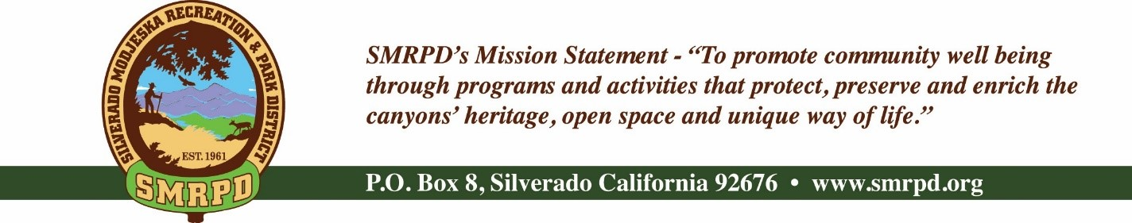
SMRPD SPECIALMEETING
Tuesday April 5th, 2022 at 6:00 PM
Silverado Community Center
27641 Silverado Canyon Road
Board of Directors |  | Staff
Isabell Kerins: | President | Laurie Briggs: | SCC Administrator
Julie “Rusty” Morris: | Vice-President | JoMarie Varela: | Administrator
Michele Agopian: | Secretary | Steve Reighart: | Caretaker
Stephanie Bailey: | Treasurer | Stephanie Dodge: | Bookkeeper
Kevin Topp: | Director

SPECIAL MEETING AGENDA

NOTE: MEETINGS WILL BE HELD IN PERSON AND BY ZOOM UNTIL FURTHER NOTICE
ZOOM LINK

PUBLIC COMMENTS: A person wishing to comment on an Agenda item should wait for the President to request comments and then unmute his or her phone, ask to make a comment, and wait for the President to recognize him/her. You have three (3) minutes to complete those comments, unless a longer time is granted. No speaker may allot his or her time to others.
Comments on Agenda items: (Pursuant to Government Code Section 54954.2 public comments will be allowed during agenda items before Board Discussions. Time limit is 3 minutes per person limited to one session per person per issue) Comments on non-Agenda items: Comments concerning matters not on the Agenda will be heard during the Public Comment section of the Agenda. A speaker's comments should be within the subject matter jurisdiction of the SMRPD.
Please note that if you are addressing the Board on items not on the Agenda, the Brown Act does not allow Board discussion of such items because they are not on the Agenda and thus were not noticed publicly. Therefore, the Board may only do the following: refer the matter to staff, ask for additional information or request a report back, or give a very limited factual response. Your comments may be placed on the Agenda for future discussion. Non-Agenda comments are limited to 3 minutes each with a total of 15 minutes.

- CALL TO ORDER
- ROLL CALL
- DISTRICT BUSINESS
    - Covid Grant
      - Discussion on return of $57,336 required by State Department due to incorrect Financials submitted

    - Concert Series Details
      - Raffle
      - Food Service
      - SMRPD role
        - Resolution #6152021-7 – Previously approved. For discussion reference.

    - Paving – All bids submitted utilizing prevailing wage, as required. Please note difference of new material quantity depth per bid. All contractors recommend removal of old asphalt and laying of new asphalt due to quality of sub-base in lieu of slurry coating which will not hold up for long due to extent of damage. This is over the $25,000 threshold and requires a formal bid process in accordance with Public Contract Code and SMRPD policy. Discussion on slurry versus new asphalt and Invitation for Bid process requirement.
      - SMRPD
        - Prestige Striping Services
        - Carmody Construction Company
        - National Paving Company Inc
        - Map

      - SCC
        - Slurry coat versus re-asphalt
          - Map Parking Lot and Access Road
          - Re-asphalt
            - Prestige
            - Carmody
            - National
          - Slurry coat bids
            - Prestige
            - National

    - Board Member and Employee Seminar, Conference, Continuing Education Reimbursement Policy

ACTION ITEM #3 : RESOLUTION 4052022-1 – BOARD MEMBER AND EMPLOYEE SEMINAR, CONFERENCE, CONTINUING EDUCATION REIMBUSREMENT POLICY

    - CARPD – Nomination of Team Rubicon for Outstanding Community Organization/Partner
      - Award Information
      - Proposed Nomination - TBD

ACTION ITEM #4 : RESOLUTION 04052022-2 – NOMINATE TEAM RUBICON FOR OUTSTANDING COMMUNITY ORGANIZATION/PARTNER FOR 2022 CARPD AWARD - TBD

- AJOURNMENT
- The next regular meeting of the SMRPD Board of Directors will be at 6:30 PM on Tuesday, April 19th, 20222 at the Modjeska Community Center and by Zoom link posted at SMRPD.org.

