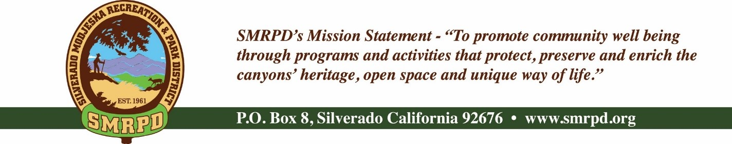
Silverado Children’s Center Oversight Committee Meeting
Wednesday, May 4th, 2022, at 2:00 PM
Silverado Community Center
27641 Silverado Canyon Road, Silverado, CA
Committee Members |  | Staff
Isabell Kerins: | President | Laurie Briggs: | SCC Director
Julie “Rusty” Morris: | Vice-President
Michele Conklin: | Treasurer
 |  | Agenda
PUBLIC COMMENTS: A person wishing to comment on an Agenda item should wait for the President to request comments and then unmute his or her phone, ask to make a comment, and wait for the President to recognize him/her. You have three (3) minutes to complete those comments, unless a longer time is granted. No speaker may allot his or her time to others.
Comments on Agenda items: Comments concerning matters on the Agenda will be heard at the time the matter is considered.
Comments on non-Agenda items: Comments concerning matters not on the Agenda will be heard during the Public Comment section of the Agenda. A speaker's comments should be within the subject matter jurisdiction of the SMRPD.
Please note that if you are addressing the Board on items not on the Agenda, the Brown Act does not allow Board discussion of such items because they are not on the Agenda and thus were not noticed publicly. Therefore, the Board may only do the following: refer the matter to staff, ask for additional information or request a report back, or give a very limited factual response. Your comments may be placed on the Agenda for future discussion. Non-Agenda comments are limited to 3 minutes each with a total of 15 minutes.

- CALL TO ORDER
- ROLL CALL
- PROGRAM REPORT UPDATE
- NEW BUSINESS
  - Covid Outbreak Policy
  - Policy versus Operations
  - New Sign on Santiago
  - Invoice payment process timeline
  - Waste Management Update
  - Financial and reporting updates
  - Summer and Fall enrollment status
- OLD BUSINESS
  - Committee Meeting Dates
  - Van – Update
  - Construction – Updates
    - Priority list
    - Garbage Disposal
  - Personnel Update
    - Social Media Coordinator
VI. ADJOURNMENT

The next regular meeting of the SCC Oversight Committee will on Thursday, June 4th, 2022, at 10:00 am at the Silverado Community Center.

