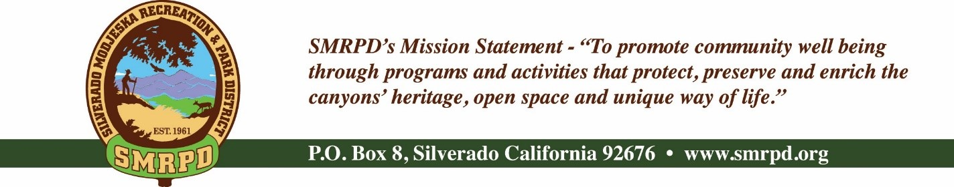
SMRPD REGULAR MEETING
Tuesday November 16th, 2021 at 6:30 pm
Modjeska Community Center
28890 Modjeska Canyon Road
Board of Directors |  | Staff
Isabell Kerins: | President | Laurie Briggs: | SCC Administrator
Julie “Rusty” Morris: | Vice-President |  | Administrator
Michele Agopian: | Secretary | Steve Reighart: | Caretaker
Stephanie Bailey: | Treasurer | Stephanie Dodge: | Bookkeeper
Kevin Topp: | Director | Sasha Sill: | Senior Services
AGENDA

NOTE: MEETINGS WILL BE HELD IN PERSON AND BY ZOOM UNTIL FURTHER NOTICE
ZOOM LINK

PUBLIC COMMENTS: A person wishing to comment on an Agenda item should wait for the President to request comments and then unmute his or her phone, ask to make a comment, and wait for the President to recognize him/her. You have three (3) minutes to complete those comments, unless a longer time is granted. No speaker may allot his or her time to others.
Comments on Agenda items: Comments concerning matters on the Agenda will be heard at the time the matter is considered.
Comments on non-Agenda items: Comments concerning matters not on the Agenda will be heard during the Public Comment section of the Agenda. A speaker's comments should be within the subject matter jurisdiction of the SMRPD.
Please note that if you are addressing the Board on items not on the Agenda, the Brown Act does not allow Board discussion of such items because they are not on the Agenda and thus were not noticed publicly. Therefore, the Board may only do the following: refer the matter to staff, ask for additional information or request a report back, or give a very limited factual response. Your comments may be placed on the Agenda for future discussion. Non-Agenda comments are limited to 3 minutes each with a total of 15 minutes.

- CALL TO ORDER
- ROLL CALL
- CONSENT CALENDAR – Michele Agopian
  - Action Item #1: Approve and file minutes of the SMRPD Board Meetings dated October 26th, 2021
- FINANCE COMMITTEE – Stephanie Bailey
  - Action Item #2: Approve and file Treasurer’s Report of SMRPD for October 2021 and SCC for October 2021
- TREASURER'S REPORT – Stephanie Bailey
  - Zelle set up for SMRPD under accounting@smrpd.org (Bookkeeper contact)
- OTHER DISTRICT BUSINESS
(Pursuant to Government Code Section 54954.2 public comments will be allowed during agenda items before Board Discussions. Time limit is 3 minutes per person limited to one session per person per issue)
  - Board Elections – To be held at December meeting
    - Per SMRPD Handbook - Officers: On an annual basis at the first meeting in December, the Board shall elect new officers. The Board members shall rotate positions of President, Vice-President, Treasurer, Secretary, and unassigned Director. No member shall hold a single position for more than one year without a majority vote of the Board. Majority vote means the vote of a majority of the members of the Board or three members of a five-person Board (Public Resources Code Section 5784.13).
  - Ad Hoc Committee – Grants
    - Per Capita Grant – Isabell Kerins
      - Presentation
    - Regional Park Program – Isabell Kerins
      - SMRPD does not qualify for this grant
    - COVID Grant – Stephanie Bailey
  - Administrator Job Opening – Isabell Kerins
    - Interviews being held
  - Personnel – Isabell Kerins
    - Deposit Form
    - Employee Checklist
    - Director Checklist
    - Time Sheet
    - Pay Schedule
    - Employment Application
  - Capri – Isabell Kerins
    - Worker’s Comp
      - New Documents
        - Wallet Card
        - Clinical Consultation Quick Reference
        - Clinical Consultation
        - Worker’s Comp Claim Mgt. Flowchart
        - Form 5020
  - Blood Drives – Rusty Morris
    - 12/21 – 10:30 to 4:30 – Free t-shirt
  - Zachary Dupre Concert Venue
    - Action Item #3 – Resolution 11162021-1 – Dedication of Silverado Community Park Stage to the Zachary Dupre Concert Venue
  - Senior Services – Sasha Sill
    - Link to Age Well menu and posting on website and social media
  - Volunteer Thank you Dinner
  - Rental Request
    - Thanksgiving Potluck – Kevin Topp
    - Christmas In the Canyon sink request
- SILVERADO CHILDREN’S CENTER (SCC) OVERSIGHT COMMITTEE – Isabell Kerins
  - Report and updates on facilities and enrollments
  - Report on Friends of Silverado Children’s Center 501c(3)
  - Staff Covid Survey - Results
- FACILITIES/SAFETY/MAINTENANCE COMMITTEE
  - Report from Facility and Safety Committee – Michele Agopian
  - Modjeska
    - Items left at park bench/Monthly Flea Market in Modjeska - Sign posted – Isabell Kerins
- RECREATION COMMITTEE
- FUNDRAISING COMMITTEE
  - Flea Market – Isabell Kerins
    - No Flea Market in November due to Thanksgiving
    - December Flea Market on 12/18
- COMMUNICATIONS COMMITTEE
  - Report from Communications Committee – Kevin Topp
  - SMRPD Website
    - Financials now on OneDrive
- OPEN SPACE AND TRAILS COMMITTEE
  - Report on Open Space and Trails Committee – Kevin Topp
- PUBLIC COMMENTS
- BOARD COMMENTS
- ADJOURNMENT
- The next regular meeting of the SMRPD Board of Directors will be at 6:30 PM on Tuesday, December 21st, 2021 at the Silverado Community Center and by Zoom link posted at SMRPD.org.

