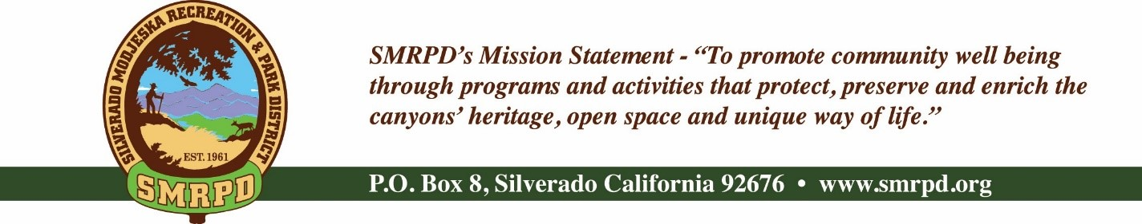
SMRPD REGULAR MEETING
Tuesday October 26th, 2021 at 6:30 pm
Silverado Community Center
27641 Silverado Canyon Road
Board of Directors |  | Staff
Isabell Kerins: | President | Laurie Briggs: | SCC Administrator
Julie “Rusty” Morris: | Vice-President |  | Administrator
Michele Agopian: | Secretary | Steve Reighart: | Caretaker
Stephanie Bailey: | Treasurer | Stephanie Dodge: | Bookkeeper
Kevin Topp: | Director
AGENDA

NOTE: MEETINGS WILL BE HELD IN PERSON AND BY ZOOM UNTIL FURTHER NOTICE
ZOOM LINK

PUBLIC COMMENTS: A person wishing to comment on an Agenda item should wait for the President to request comments and then unmute his or her phone, ask to make a comment, and wait for the President to recognize him/her. You have three (3) minutes to complete those comments, unless a longer time is granted. No speaker may allot his or her time to others.
Comments on Agenda items: Comments concerning matters on the Agenda will be heard at the time the matter is considered.
Comments on non-Agenda items: Comments concerning matters not on the Agenda will be heard during the Public Comment section of the Agenda. A speaker's comments should be within the subject matter jurisdiction of the SMRPD.
Please note that if you are addressing the Board on items not on the Agenda, the Brown Act does not allow Board discussion of such items because they are not on the Agenda and thus were not noticed publicly. Therefore, the Board may only do the following: refer the matter to staff, ask for additional information or request a report back, or give a very limited factual response. Your comments may be placed on the Agenda for future discussion. Non-Agenda comments are limited to 3 minutes each with a total of 15 minutes.

- CALL TO ORDER
- ROLL CALL
- CONSENT CALENDAR – Michele Agopian
  - Action Item #1: Approve and file minutes of the SMRPD Board Meetings dated August 2021, October 19th, 2021, and Special Meeting dated 10/19/2021
- FINANCE COMMITTEE – Stephanie Bailey
  - Action Item #2: Approve and file Treasurer’s Report of SMRPD for August 2021 and September 2021 and SCC for August 2021and September 2021
- TREASURER'S REPORT – Stephanie Bailey
- OTHER DISTRICT BUSINESS
(Pursuant to Government Code Section 54954.2 public comments will be allowed during agenda items before Board Discussions. Time limit is 3 minutes per person limited to one session per person per issue)
  - Survey– Isabell Kerins
    - Final Results , Summary, Recommended Projects
  - Ad Hoc Committee for Inter-Canyon Clean-up Day 9/18/2021 – Isabell Kerins
  - Ad Hoc Committee – Grants
    - Per Capita Grant – Isabell Kerins
      - Action Item #3: Resolution #10192021-1 – Resolution Approving Applications for Per Capita Grant Funds
      - Recommendations for Per Capita Grant Projects
    - Regional Park Program – Stephanie Bailey
      - Action Item #4 Resolution #10192021-2 – Resolution Approving Application for Regional Park Program Grant
    - COVID Grant – Stephanie Bailey
      - Action Item #5 Resolution #10192021-3 – Resolution Approving Application for COVID Grant
      - Grant applied for 10/15/2021 due to deadline
  - Administrator Job Opening – Isabell Kerins
    - Job Description
    - Action Item #6 - Approve SMRPD Administrator Job Description
    - Post job opening
  - SMRPD Payroll Set-up Complete – Isabell Kerins
  - Personnel – Isabell Kerins
    - SMRPD – Employee Direct Deposit Authorization form
  - Employee Data Request – Isabell Kerins
    - Transparent California
  - Document Updates – Isabell Kerins
    - Reimbursement Form
    - Check Request
  - Employee Required Insurance Documents and Sexual Harassment Training – Isabell Kerins
  - Capri – Isabell Kerins
    - Worker’s Comp Annual Update
  - Brown Act Legislation
  - Blood Drives – Rusty Morris
    - 9/15 – 12 to 7 – Results
    - 12/21 – 10:30 to 4:30 – Free t-shirt
  - Zachary Dupre Concert Venue – Kevin Topp
  - Senior Services – Isabell Kerins
  - Rental Policy– Isabell Kerins
    - Special Event Wavier Discussion
  - Modjeska – Unapproved Pilates program – Kevin Topp
- SILVERADO CHILDREN’S CENTER (SCC) OVERSIGHT COMMITTEE – Isabell Kerins
  - Report and updates on facilities and enrollments
  - Report on Friends of Silverado Children’s Center 501c(3)
  - Follow up to Canyon Beat article
  - Staff Covid Survey
- FACILITIES/SAFETY/MAINTENANCE COMMITTEE
  - Report from Facility and Safety Committee – Michele Agopian
  - Health Permit Update – Rusty Morris/Michele Agopian
  - Modjeska
    - Bulletin board at Santiago Canyon Road and Modjeska Canyon – Rusty Martin
    - Items left at park bench/Monthly Flea Market in Modjeska discussion – Isabell Kerins
    - Meeting held with Modjeska residents – Isabell Kerins
- RECREATION COMMITTEE
  - Concert Series and Hamburger Stand
    - 9/18 Results – Rusty Morris
    - Review policy
- FUNDRAISING COMMITTEE
  - Flea Market – Isabell Kerins
    - July, August, September, October Update
    - No Flea Market in November due to Thanksgiving
- COMMUNICATIONS COMMITTEE
  - Report from Communications Committee – Kevin Topp
  - Email List - Add Rattlesnake Aversion Training contacts – Michele Agopian
  - SMRPD Website – Financials need uploading ASAP
- OPEN SPACE AND TRAILS COMMITTEE
  - Report on Open Space and Trails Committee – Kevin Topp
- PUBLIC COMMENTS
- BOARD COMMENTS
- CLOSED SESSION: REAL PROPERTY NEGOTIATIONS – PURSUANT TO GOVT. CODE SECTION 54956.8
a. Property- Riviera and parcel adjacent to Silverado Community Center, Agency Negotiator: Board Ad Hoc Committee. Negotiation with St.. Michael’s Abbey – Father Miguel. Under negotiation: possible price and terms
- ADJOURNMENT
- The next regular meeting of the SMRPD Board of Directors will be at 6:30 PM on Tuesday, November 16th , 2021 at the Modjeska Community Center and by Zoom link posted at SMRPD.org.

